CSE460
Practice Sheet

CMOS Logic
Q-1. Suppose you want to design a circuit that includes three inputs ($x_{1}, x_{2}, x_{3}$), and one output ($f$). Following is the truth table of the desired circuit.
$x_{1}$ | $x_{2}$ | $x_{3}$ | $f$
0 | 0 | 0 | 1
0 | 0 | 1 | 0
0 | 1 | 0 | 1
0 | 1 | 1 | 0
1 | 0 | 0 | 1
1 | 0 | 1 | 0
1 | 1 | 0 | 1
1 | 1 | 1 | d
Find the logic expression using k-map and implement the logic expression using only 2x1 mux (Don’t use any logic gate; you can use more than one 2x1 mux).
Q-2. Implement an XNOR gate using a single 2x1 mux.
Q-3. Form a truth table and identify the logic expression of the given circuit.
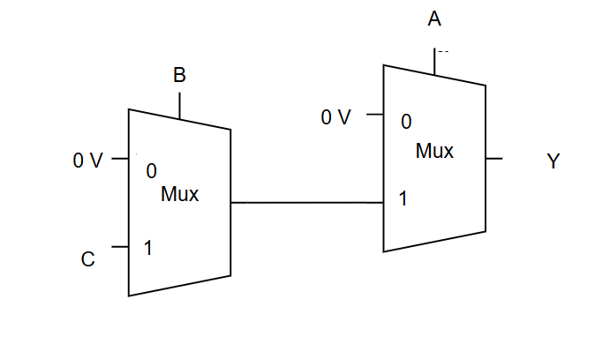
Q-4: Compare the number of required transistors for implementing a 2x1 mux using CMOS and transmission gates. (Show both implementation diagram )
Q-5. Design a 4x1 Mux using minimum number of nmos pass transistors. You are only given the input signals s, D0, D1, D2, D3. Using the 4x1 Mux, design a 8x1 Mux( you cannot use any other Mux).
Q-6. Take a room light control system for example. The light should turn ON automatically only:
- if the main power switch is ON
- and either the wall switch is ON or a person is detected by the motion sensor

Take the inputs as following:
- A = Main power switch (1 = ON, 0 = OFF)
- B = Wall switch (1 = ON, 0 = OFF)
- C = Motion sensor (1 = detects movement, 0 = no movement).
(a) Find the expression for output f (1 = Light ON, 0 = Light OFF).
(b) Design the circuit using transmission gates.

Q-7. For the following truth table:
X1 | X2 | X3 | X4 | f
0 | 0 | 0 | 0 | 0
0 | 0 | 0 | 1 | 0
0 | 0 | 1 | 0 | 1
0 | 0 | 1 | 1 | 1
0 | 1 | 0 | 0 | 0
0 | 1 | 0 | 1 | 0
0 | 1 | 1 | 0 | 1
0 | 1 | 1 | 1 | 1
1 | 0 | 0 | 0 | 0
1 | 0 | 0 | 1 | 1
1 | 0 | 1 | 0 | 1
1 | 0 | 1 | 1 | d
1 | 1 | 0 | 0 | 0
1 | 1 | 0 | 1 | 1
1 | 1 | 1 | 0 | 1
1 | 1 | 1 | 1 | d

- Find the expression for f using K-map.
- Now, design the circuit using CMOS logic.

Q-8. Implement the following function using only transmission gate logic:
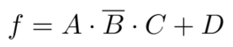

Q-9. Write truth table of a 4 to 1 mux whose select pins are A, B and Input lines are I₀ ,I₁ , I₂ , I₃

Q-10. Find the simplified output logic expression Y=F(A,B,C) using karnaugh’s map rule
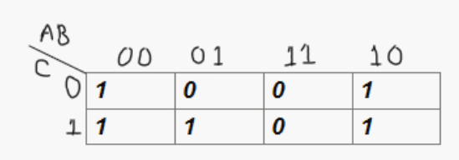
Q-11. Find out the voltages at V1, V2, V3, V4 , V5 when VDD=4V,and Vx= 3V, Vtn= 0.5V , |Vtp|= 0.2V
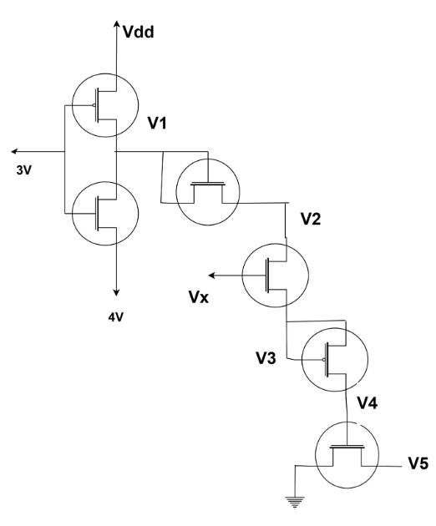
Q-12: For the following circuit, draw Qa, Qb and Qc:
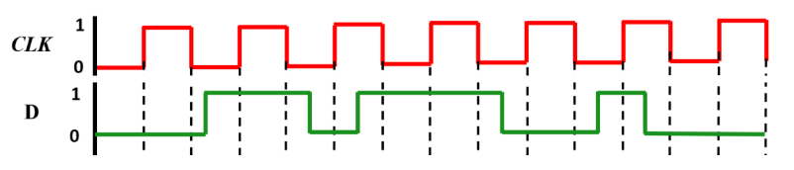
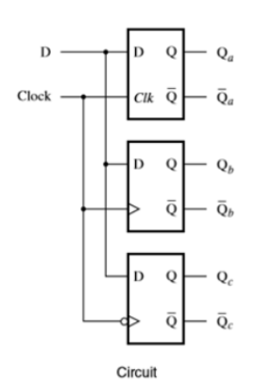
Q-13. The input (D) output(Q) relationship of the device in figure is given below
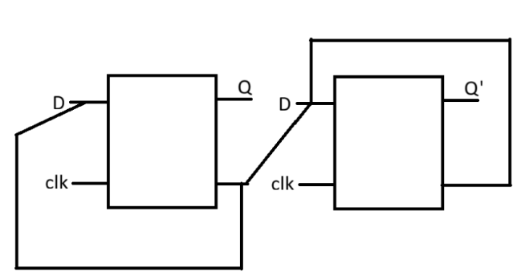
(a) Identify the block device from given waveform below
(b) Draw output Q’, initially assume D on the left device to be 0
(c) What function does the circuit perform?
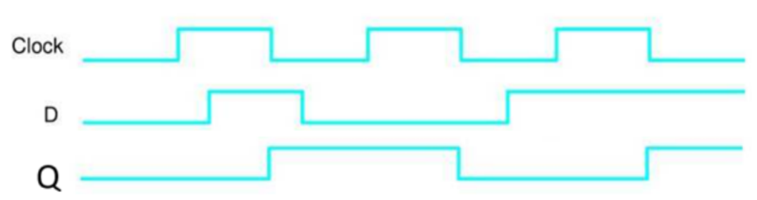
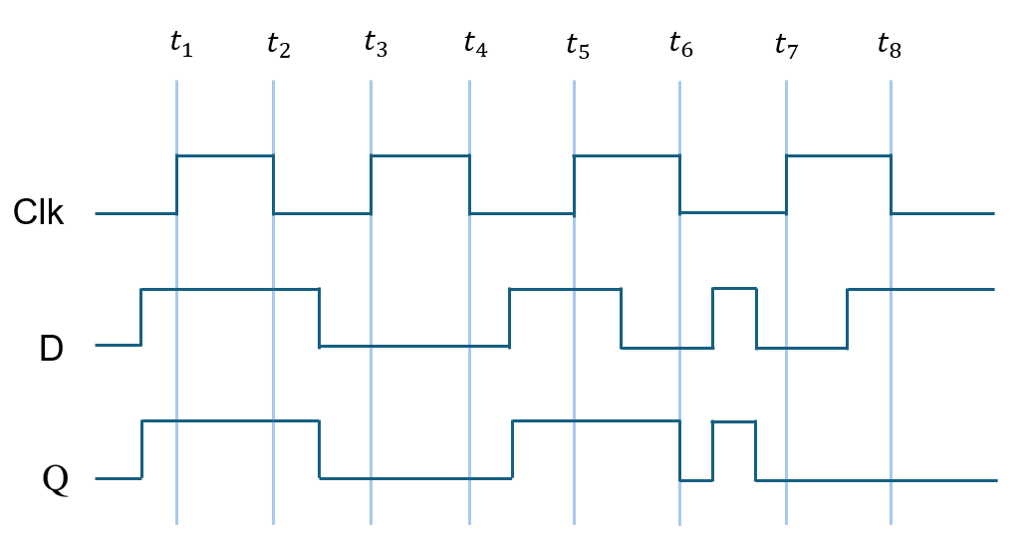
Q-14.
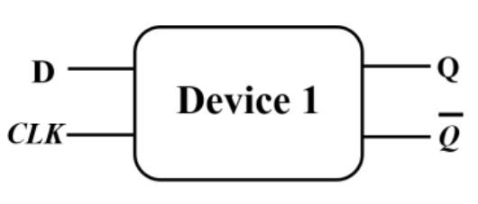

(a) Identify Device-1 and implement it using transmission gates.
(b) Draw the output waveform based on the following circuit:
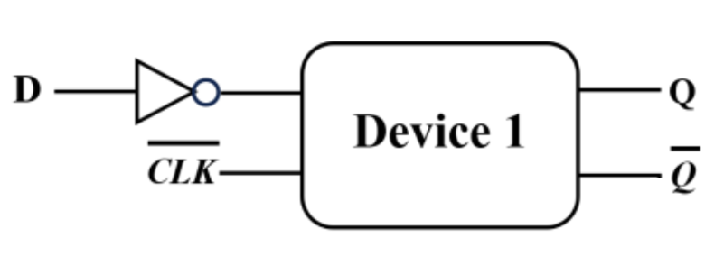
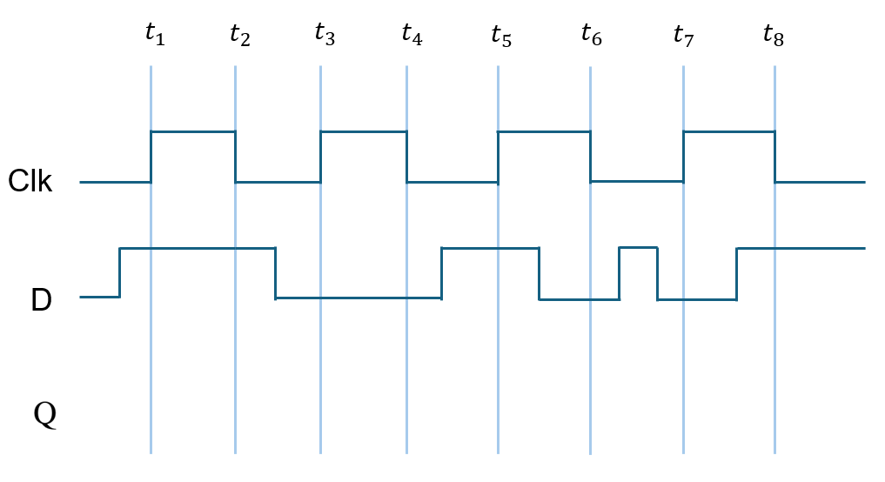
Q-15: Identify Device 1 and draw the waveforms in the grid given above for the right circuit of Fig. 1. Determine if the circuit is a negative-edge/level-triggered or positive-edge/level-triggered flip-flop/latch?
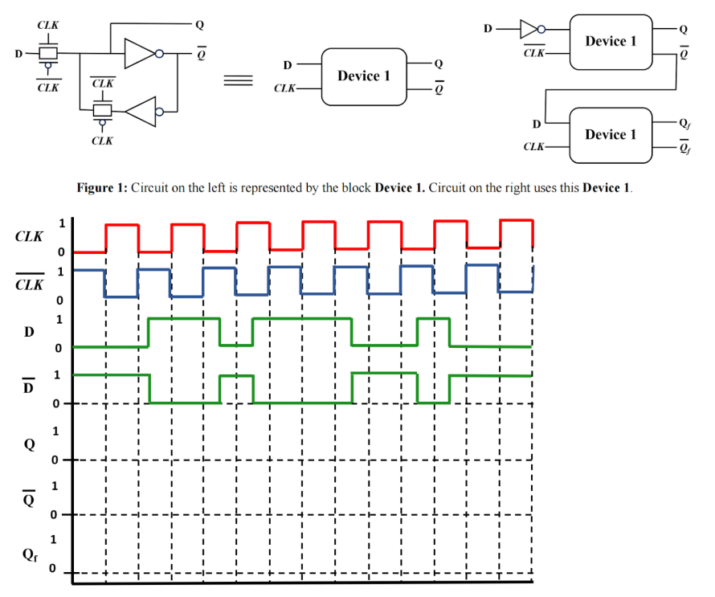
Q-16. 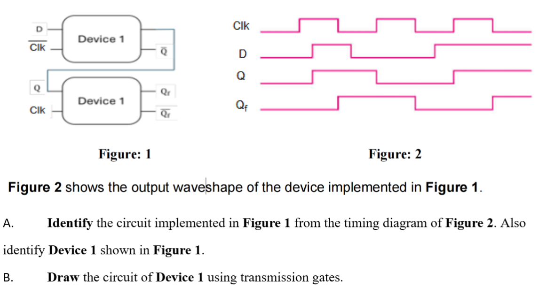
Q-17.
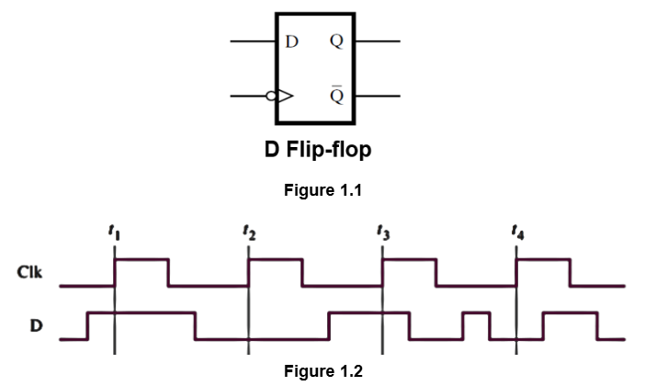

(a) | State the difference between D Latch and D Flip-Flop.  Implement the D Flip-Flop ( Given in the above Figure ) using D Latch.
(b) | Draw the output of the D Flip-Flop when Clk and D of Figure 1.2 are applied to the D Flip-Flop.

Finite State Machine (FSM)
Q-1. 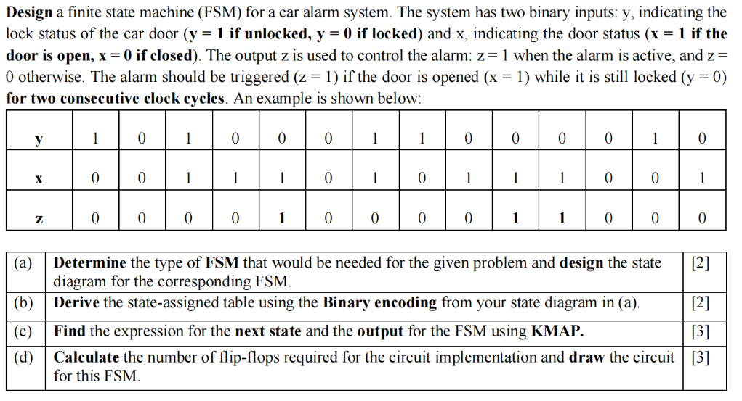
Q-2: Design an FSM (mealy) that detects either ’10’ or ’1011’. Provide
• State diagram
• State Assigned table
• The final circuit using logic gates and FF

Q-3: A system has one input, A, and two outputs, X and Y.
The output X should be 1 if the input A has been 0 for three consecutive cycles.
The output Y should be 1 if the input sequence 010 occurs consecutively. For example,

A | 1 | 0 | 0 | 0 | 0 | 1 | 0 | 0 | 1 | 0 | 1 | 0 | 0 | 0
X | 0 | 0 | 0 | 0 | 1 | 1 | 0 | 0 | 0 | 0 | 0 | 0 | 0 | 0
Y | 0 | 0 | 0 | 0 | 0 | 0 | 0 | 1 | 0 | 0 | 1 | 0 | 1 | 0

(a) Draw the state diagram for the corresponding FSM.
(b) Derive the state-assigned table from the state diagram.
(c) Find the expression for the next state and the output for the FSM using KMAP.

Q-4: A sequential circuit has two inputs, w1 and w2, and an output, z. Its function is to compare the input sequences on the two inputs. If w1 = w2 during any four consecutive clock cycles, the circuit produces z = 1; otherwise, z = 0. For example
w1 | 0 | 1 | 1 | 0 | 1 | 1 | 1 | 0 | 0 | 0 | 1 | 1 | 0 | 1
w2 | 1 | 1 | 1 | 0 | 1 | 0 | 1 | 0 | 0 | 0 | 1 | 1 | 1 | 0
z | 0 | 0 | 0 | 0 | 1 | 0 | 0 | 0 | 0 | 1 | 1 | 1 | 0 | 0
Draw the state diagram of the corresponding FSM.
Q-5:
Suppose you want to design an FSM that will detect sequences of alphabet. There will be four different types of possible input alphabets (A, B, C, D). When the sequence of the alphabets is AACC, the output of the FSM will be high (1), otherwise it will remain low (0).
Input (w) | A | B | A | A | C | C | A | C
Output  (z) | 0 | 0 | 0 | 0 | 0 | 1 | 0 | 0

(a) | Identify the type of FSM and draw the state diagram of the FSM. | [6]
(b) | Make a state assigned table using the gray encoding. | [5]
(c) | Find the expression of the output (z) using the state assigned table from (b). | [4]

